Green Fund Project
Final Report
This report may be published on the SIU Sustainability website.

Name of person(s) completing report: Alex Barnes
Identify if the person completing report is a student, faculty, and/or staff: Student
Department: College of Agriculture
Contact Phone and email address: (312)504-8157, alexandra.barnes@siu.edu
Faculty Advisor (if applicable): Stephanie Dukat
Project Title: Woodshop Biochar Production
Project ID #:
Award Date: June 2020
Completion Date: 4/23/21
Total Funds Used: 140

- Provide a summary of your project/project experience.
  - This project was to take waste wood from the Woodshop and convert it into biochar, a process which diverts wood from landfills, sequesters carbon, and improves soil and environmental health. This project was initially proposed by Alex Hadley, who handed it off to me (Alex Barnes) before graduating in December 2020. We initially planned to work with Dr. Paul Anderson on his barrel kiln design, but because of funding limitations and a difference in production philosophies, I took the project in a different direction and built a soil pit kiln. The SIU Sustainable farm was kind enough to host the kiln on their site, so I was finally able to build it and do our first burn in April 2020. I am currently gathering students to form an RSO who will continue making biochar after I graduate, and am finding applications for biochar at SIU.
- Provide a summary of your results (environmental, social, and/or economic) including quantifiable data as appropriate (ex. # of individuals reached, lbs. diverted from landfill, energy saved, etc.).
  - We diverted some wood waste (I had no way to measure how much) from landfills and created 6 gallons of biochar. This was from a single firing, and I plan to do one firing a month for the foreseeable future. This saves a lot of wood waste and makes a significant amount of biochar. Our project spans even further because some of the biochar will be used for research projects with environmental implications next year, which can affect change on a scale even wider than our campus.
- Summarize how your project promoted the Green Fee/Sustainability on campus including, but not limited to, flyers created, screenshots of website, signage, etc. Please include website links, if applicable. (Reminder: you are required to promote your project using at least 2 items from the awardee website promotion list.)
  - I credited the green fee in every presentation about the project and will continue to do so, and included the green fund marker on posters in the woodshop advertising the project.
- Provide evidence of how you used the Green Fund Marker in your project.
I can’t put stickers on anything, because the fire would damage them, but I included the marker on posters put up in the woodshop. This is the poster:
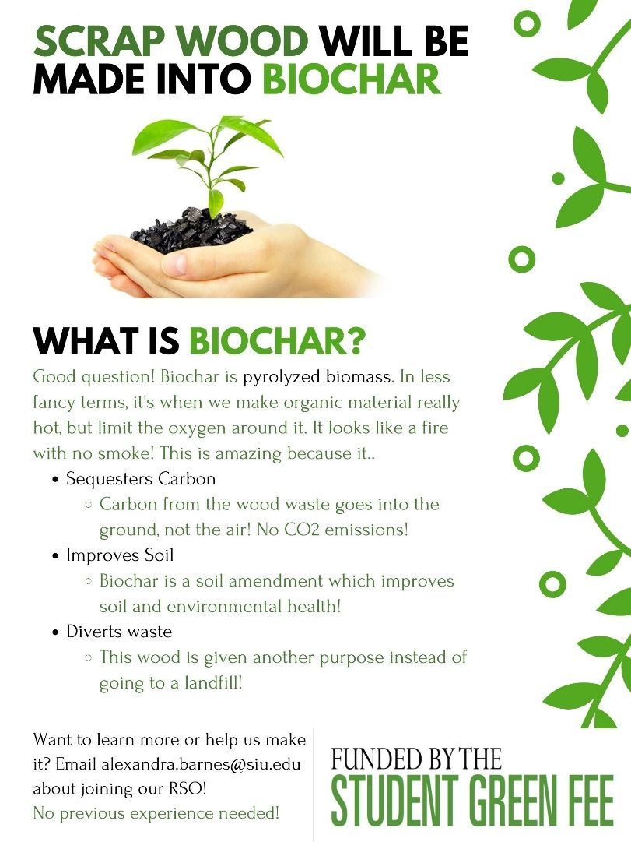
- Is there anything you would do differently if you were to do a similar project in the future? If so, please describe.
  - There was a breakdown in communication between the initial student who proposed the project and me, as we both had very busy schedules and did not want to meet in person because of covid. It would have been helpful if I could have seen the proposal materials (like the initial write up and budget) earlier on so that I had a better understanding of what the project was, but I should have taken the initiative to ask for those materials from green fund administration rather than only relying on my teammate. Getting permission to put the kiln anywhere was also difficult, as it involves fire, so I would definitely work on my approach in that area.
- Provide as an attachment to the email (see email address below) a minimum of 5 digital images. A minimum of one of the five images should include a person. Images should be of high a quality as possible and be attached in jpg format, if available. Images will be used to promote interest in sustainability projects on campus and may be used on our website and in other promotional material. These can be photos of the progress of the project or the completed project. Provide captions for photos here.
- In 2-5 sentences, describe what you learned from completing the Green Fund grant process. Include a detailed response (Do not simply respond “yes” or “no.”) to at least one of the following questions to help us understand how this project has impacted your overall university experience.
  - Do you have a different understanding of sustainability now than you did at the beginning of the process?
    - This project reinforced my experience in persuading people who are apprehensive to sustainable projects. Faculty and other students were not very receptive when I was looking for help with starting or progressing this project, but after seeing the finished product, were excited and eager to participate in the future. This sustainability project, along with many others, taught me that anyone can learn to be passionate about sustainability.
  - Did you apply knowledge or skills learned from courses at SIU?
    - I did research on biochar production in my Trends in Soil Science class, which in addition to my years of biochar production experience, helped me greatly in this process.
  - Did the completion of the Green Fund grant process help to prepare you for your future career opportunities?
    - Definitely, I feel that I have learned a lot about communicating with others, especially those wary about sustainability or projects that they are unfamiliar with. After practicing talking about biochar with people all year, I was able to give a very successful presentation about biochar at the end of my second semester. I could tell that my audience was really excited about sustainable waste repurposement in an agricultural setting, and even got some students interested in the biochar RSO for next year.
- List suggestions for the SIU Sustainability Council to improve the Green Fund Award Process here:
The people I spoke to at the Sustainability Council were so helpful, always responding quickly when I reached out for help. Some scheduled check ins with students doing projects to make sure they are on track may be helpful, but I also see the value in giving students room to succeed on their own (learning valuable lessons along the way)

Final Report forms should be sent electronically, in editable Microsoft Word format, to greenfund@siu.edu. This should be completed before requesting final reimbursement. A Sustainability Council designate will review final reports before releasing funds.

