Green Fund Project
Final Report
This report may be published on the SIU Sustainability website.

Name of person(s) completing report: Jyotsna Kapur with Jacob Coddington and Carly Kasicki
Identify if the person completing report is a student, faculty, and/or staff: Faculty and students
Department: University Honors Program
Contact Phone and email address: 453-1688; jkapur@siu.edu
Faculty Advisor (if applicable): Jyotsna Kapur
Project Title: Innovation and Sustainability
Project ID #: 19SP112
Award Date: June 2019
Completion Date: December 2019
Total Funds Used: $3260

- Provide a summary of your project/project experience.
In Fall 2019, the University Honors program offered an interdisciplinary class, Innovations in Sustainability: Surviving in a Changing World. This came after a year long planning process in which Carly and Jake had taken the lead, to bring together 13 faculty and community members to present on their work as it related to sustainability. See the attached syllabus. For their final projects, students worked in groups to identify and create solutions or plans to resolve issues of sustainability on campus. These projects were presented to the campus and local community at the end of class.

- Provide a summary of your results (environmental, social, and/or economic) including quantifiable data as appropriate (ex. # of individuals reached, lbs. diverted from landfill, energy saved, etc.).
The class was an experiment in student generated course content, thus in developing university level curriculum on sustainability. In Fall 2020, Jyotsna Kapur will offer another iteration of this class, called Sustainability and the Collective Imagination. The Fall 2019 class had 16 students enrolled and the same is expected for Fall 2020. Each of the 16 students enrolled in Fall 2019 is emerging as a leader on sustainability on campus. One group, has introduced a week on sustainability in UCOL 101, a class taken by every SIU student. Another group of students is working on a bee garden. The third group developed a bike plan in collaboration with University Housing. And, the fourth group developed a plan to encourage recycling. All of the students understood the holistic nature of sustainability studies—and will be bringing those considerations in their academic studies henceforth. At least two students, intend to minor in sustainability studies and changed their plans after this class.

- Summarize how your project promoted the Green Fee/Sustainability on campus including, but not limited to, flyers created, screenshots of website, signage, etc. Please include website links, if applicable. (Reminder: you are required to promote your project using at least 2 items from the awardee website promotion list.)
Students in Innovations is Sustainability: Surviving in a Changing World were quickly exposed to the Sustainability Office and all their initiatives. Geory Kurtzals and Karen Schauwecker came into the class on the first day and discussed sustainability. Geory was then a continuous visitor and student mentor throughout the semester, constantly meeting with teams to give wisdom about sustainability on campus and advice to students on who they should talk to about their projects. We directly discussed the Green Fund with students and pushed for them to look into applying for it in the future. The class also generated at least one project for a future green fee grant: The Bee Garden, is planning on applying for a Green Fund Proposal this Spring.

Jacob Coddington and Carly Kasicki brought up that the course was funded by the Green Fund on the first day of class, at the Honors Faculty Showcase, and Final Presentation Showcase. This can be seen on the slides 6 and 22 of the presentation below and on the bottom of the flier for the Final Presentations.
https://docs.google.com/presentation/d/1zqvWaaGjH9gJbWQsjnXWgiozATbeSdqeSxSN90zYqQc/edit?usp=sharing
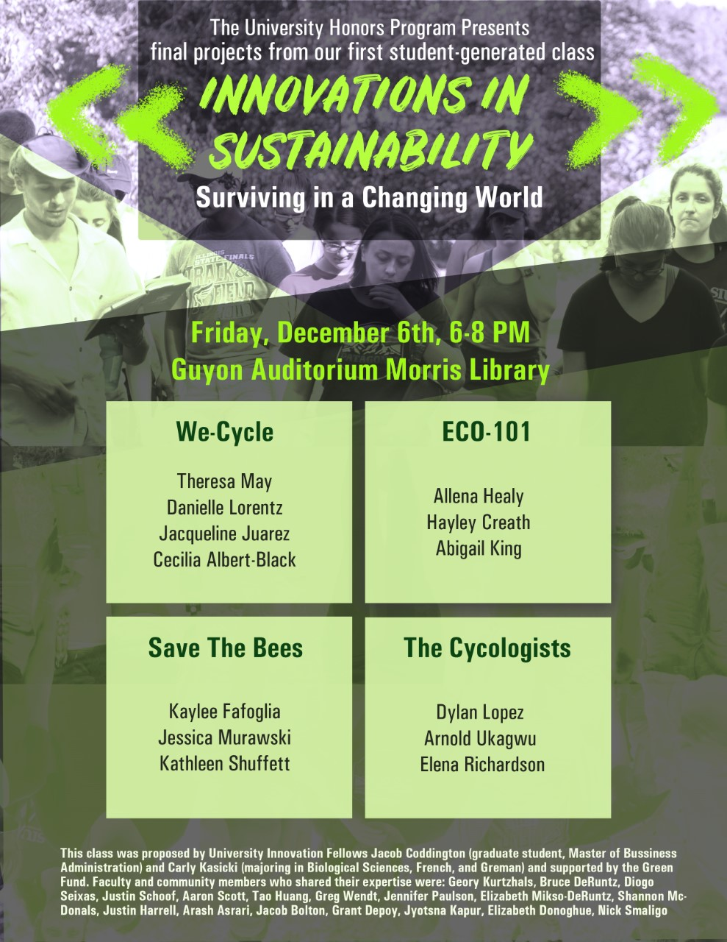

- Provide evidence of how you used the Green Fund Marker in your project.
While the only physical evidence of the use of the Green Fund Marker in our project is the powerpoint presentation above, we promoted the Green Fund through our class and class promotion. Some examples of this include:
- Having Geory Kurtzhal speak to the class of 13 students about the green fund grant and talking through potential project proposals with them.
- Green Fund Marker was used in multiple powerpoint presentations where we spoke about the class and the honors program.
- Green Fund Marker will be used in upcoming Honors Program material about the class

- Is there anything you would do differently if you were to do a similar project in the future? If so, please describe.
We would like to change parts of the formatting of the class. For example, we are going to give students more time to complete their projects. We will do this by having a couple less speakers in the beginning of the class and move up the time for students to work on their projects. We would also like to teach the students ways to brainstorm. This will help the students think more outside the box in their projects.

We will also add an analysis of the structural reasons that hinder or support efforts towards sustainability. The class tended to focus more on design thinking, with some input from science and engineering. However, the humanities and social sciences were neglected. The Fall 2020 iteration of this class, with the title, Sustainability and the Collective Imagination, will address this lacuna.

Lastly, we would like to work more cohesively throughout the course with Geory Kurtzhal, from the Sustainability Office, and the Art and Design Department. We believe Kurtzhal will connect the students with a mentor that can provide excellent resources for where/who the students can go/talk to for their projects. The Art and Design Department will help the students explore their creative ideas and push themselves to accomplish more than what they originally believed they could.

- Provide as an attachment to the email (see email address below) a minimum of 5 digital images. A minimum of one of the five images should include a person. Images should be of high a quality as possible and be attached in jpg format, if available. Images will be used to promote interest in sustainability projects on campus and may be used on our website and in other promotional material. These can be photos of the progress of the project or the completed project. Provide captions for photos here.
Photos also in an attachment:
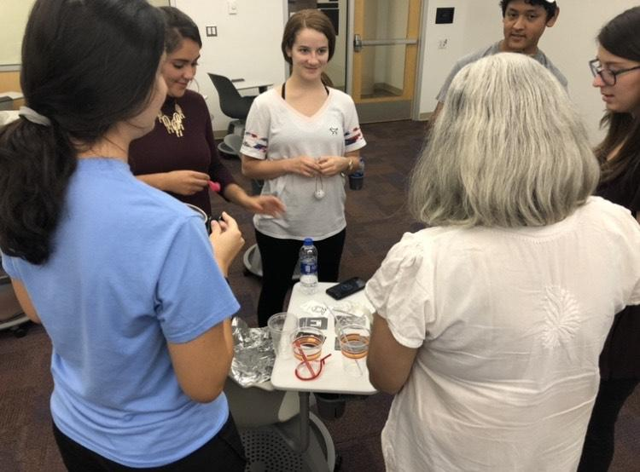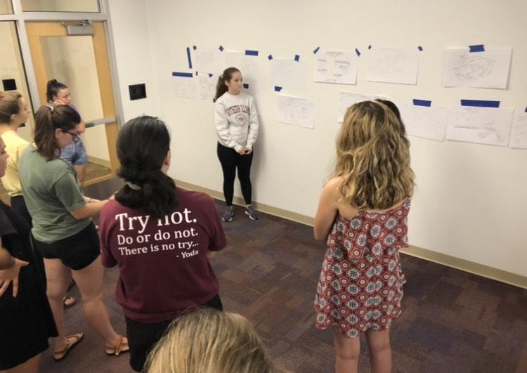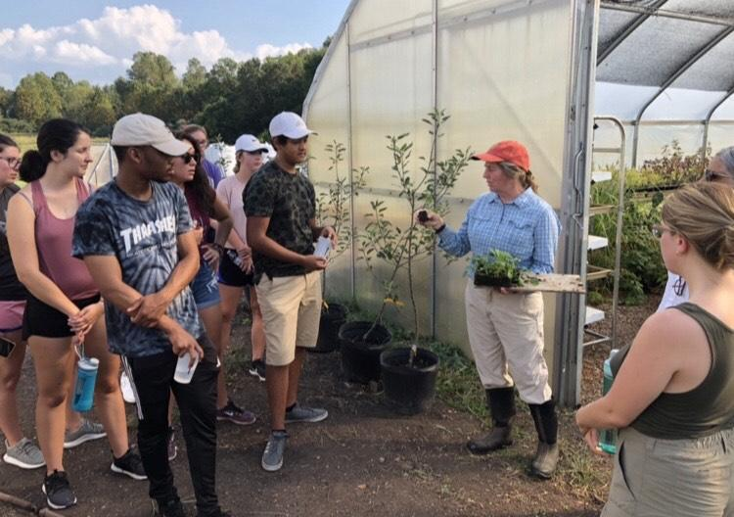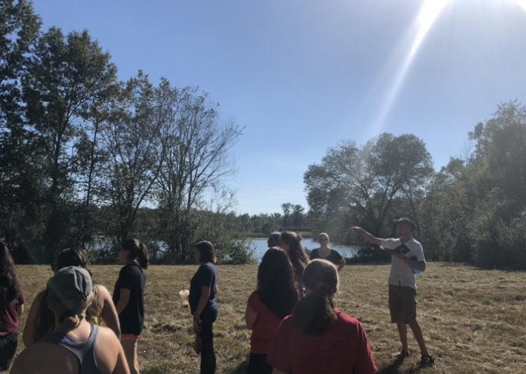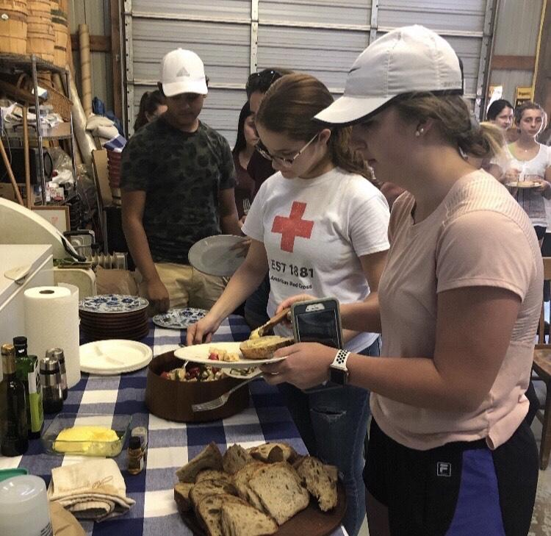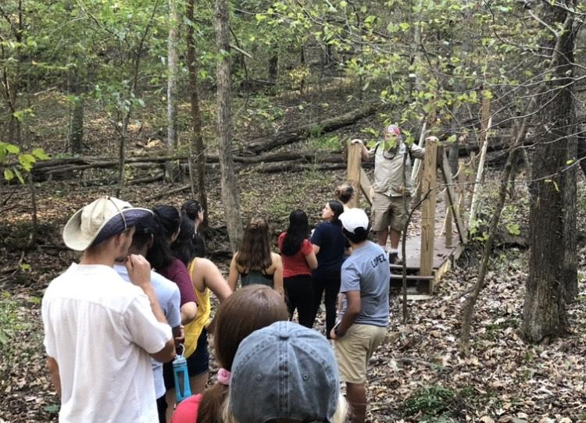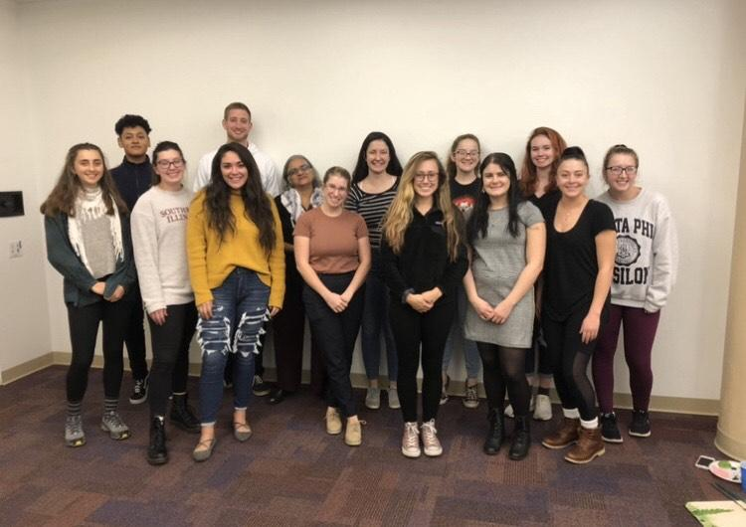

Picture 1 (Top Left)
Students work with class facilitator Dr. Jyotsna Kapur to come up with “rapid prototypes” during a design challenge.
Picture 2 (Top Right)
Students present their “Wicked” sustainability problems during the Art and Design week of the class.
Picture 3
Jill Rendleman teaches the students about sustainable agriculture at the organic “All Seasons Farm”
Picture 4
Forestry student and co-teacher of “The Evergreen Model” Grant Depoy takes the group on a tour of Evergreen Terrace.
Picture 5
The Students of “Innovations in Sustainability: Surviving in a Changing World” enjoy a sustainable meal at “All Seasons Farm”
Picture 6
Environmental educator Steve Gariepy leads the students on a hike around SIU’s “Touch of Nature”
Picture 7
A group picture on the last day of class.
- In 2-5 sentences, describe what you learned from completing the Green Fund grant process. Include a detailed response (Do not simply respond “yes” or “no.”) to at least one of the following questions to help us understand how this project has impacted your overall university experience.
We learned that while it can be difficult at times managing multiple stakeholders in a project, the more support you have for an initiative, the better. We also learned that challenges that come from teaching a college course, and were humbled by the experience.

We also learned a great deal about sustainability in fields that we hadn’t been introduced to prior to the project, and opened our eyes to the challenges they’re facing. Climate change is truly a “wicked problem”, and we now know more than ever it is going to take a concerted global effort to make the necessary changes.

  - Do you have a different understanding of sustainability now than you did at the beginning of the process?
Yes, I further understand how various fields view and try to tackle sustainability. Each expert had so much insight into the specific difficulties that they face in their fields in terms of working sustainably. I also understand more of what we can do as individuals to help tackle the overlying problem of Climate Change.

  - Did you apply knowledge or skills learned from courses at SIU?
We utilized our experiences attending classes over our time at SIU to help formulate portions of this course. We also applied team communication skills learned through group projects in past classes, and stressed the importance of these skills to our students.

  - Did the completion of the Green Fund grant process help to prepare you for your future career opportunities?
Completing this Green Fund grant prepared us for future career opportunities through strengthening and developing our project management skills. Regardless of the job field you go into, there are always multi-stakeholder projects that must be completed. Thankfully, through this Green Fund process, we got the experience of managing and completing a project involving over a dozen different stakeholders from SIU and the Carbondale Community.

- List suggestions for the SIU Sustainability Council to improve the Green Fund Award Process here:
  - A reminder part-way through the semesters to remind projects to incorporate the Green Fund logo in project promotion.
  - Offer potential ways to market the Green Fund’s affiliation with the project

351M-Multicultural/ 351O-Social Science/351U-Humanities: INNOVATIONS IN SUSTAINABILITY: SURVIVING IN A CHANGING WORLD

Fall 2019: W 3-6, Morris 724
This course was generated by Jacob Coddington and Carly Kasicki (University Innovation Fellows)
Faculty Coordinator: Jyotsna Kapur, Professor, Cinema and Photography & Director, University Honors Program

Jyotsna Kapur: jkapur@siu.edu Office: 110A Morris Phone: 453-1688
Office Hours: Walk-ins (between 10:00 AM-5:00 PM) are welcome, but to make sure that we can chat uninterrupted please stop by the Honors Front desk and make an appointment.

Jacob Coddington: jacob.coddington@siu.edu and Carly Kasicki: carly.kasicki@siu.edu

This is a student-generated course that brings together faculty from the arts, humanities, sciences, and the social sciences to consider the challenges to our survival as a species; and design as a way to conceptualize and find solutions towards sustainable living. The course was initiated by University Innovation Fellows, Jacob Coddington (Graduate student, Master of Business Administration) and Carly Kasicki (majoring in Biological Sciences, French, and German). The course is itself an example of innovation, with students bringing together faculty to address the critical issue of survival -- thus, taking ownership over their education and the richness of knowledge and experience on our campus. It has been in preparation for months and should be an adventure in exploring the possibilities of a comprehensive research university, such as ours.
Weekly meetings will include lectures, discussions, field trips, and project-based work in groups and individually. The first half of the class will be led by faculty, introducing students to concepts, approaches, and histories from their disciplinary strengths; and helping you identify the problem you would like to work on in this class. In the second part, students will work primarily in groups, on specific issues that you have selected to work on.

Course Objectives:
By the end of the course, students should have acquired:
- A working knowledge of how various academic disciplines and communities understand and define sustainability.
- An understanding of the history and practice of design as a way to formulate problems and to construct, create, and find solutions that are aware of the aesthetic, functional, political-economic, social, and cultural dimensions of their proposals.
- Experience in working collaboratively on formulating problems, documenting the process of enquiry, and creating plans and/or practical solutions
- Basic skills in presenting and communicating research and findings with others, including, making choices of medium based on the project goals.
- A deepened ability for self-reflection and a sense of ethical responsibility to oneself and others

Readings/texts
Everything is available online or on D2L other than the following:
Heschong, Lisa. Thermal Delight. Boston, MA: The MIT Press, 1979.
Readings must be done prior to the class they are assigned for.
Assignments:
- Idea book: 10%: Keep a journal in which you respond to the weekly readings. Your responses should consider: What did you find most compelling about the readings? What significant aspect did the author/s leave out? If they did, why do you think they did that? Was it the time period, author bias, or available technology? Note passages, sentences, terms you found significant. Finally, what ideas did the reading generate for you? It could be an observation, a plan, something to follow up on. The idea book should include materials other than words, e.g., pictures, poems, tables, data, printed notes—whatever is necessary for you. Name your book. You must always have this book with you in class. In certain classes, you will be given an assignment. This will be your journal entry for that week and can be completed before or after the class.
- Group portfolio: 10%: From Week 4, your group will keep a website/portfolio/blog/folder where you will keep your research, highlighting projects, ideas or problems that you found in association with the assigned readings for the class, record of your experiences and materials you found. This is material that you generate as much for yourself as for others in class. This will also come in handy when you create your group presentations to be workshopped Week 9.
- Project proposal for the final project: 15%. The proposal should formulate the problem; describe your research, including the method and/or process; outline plan of action; budget; and time line. 3-5 pages. This will be turned in by the group as a whole and must also be put on the group’s webpage.
- Final Project 50%.
- 10%: evaluation by peers and self-evaluation of individual contribution to the project.
- 10% for the presentation of your project.
- 30% on the project and report on challenges, insights, and future recommendations.
- Class participation 15%

Week 1: Introductions - to each other and the course (08/21)
- Carly and Jake: a vision statement and introduction to the class; Jyotsna syllabus
- Sustainability: What does that mean?
Geory Kurtzhals (Director, Office of Sustainability)
- Leadership and team building:
Bruce DeRuntz and Diogo Seixas (Engineering and Leadership Development Program) Students will be broken into groups: 4 groups of 4 each or 5 groups of 3 each will be formed.
Assignment/journal entry:
1. The United Nations Sustainable Development Goals (UNSDGs) help to focus priorities around holistic, world-wide goals.
-Review the following Official UN SDG websites:
- https://www.un.org/sustainabledevelopment/sustainable-development-goals/
- https://sustainabledevelopment.un.org/
- Read about UN News: https://news.un.org/en/
-Respond to the following 3 items in 1-2 pages, double spaced:
- The 17 SDGs are meant to be interpreted as parts of a whole systems approach, as opposed to distinct and separate goals to be worked on individually. When intact, the goals are interrelated and mutually reinforcing aspects of the human experience. Choose 2 goals and explain the interdependence.
- Choose 1 goal. Find a local organization that addresses this goal in our area. How does this organization implement the SDGs in ways that are sensitive to the bio-cultural uniqueness of your place? Contrast this organization to one that does similar work in another area of the globe. How does their approach differ based on societal and environmental attributes of the region?
- Could SIU more fully address the UNSDGs? What would you like to see SIU do? Why?
2. Explore the Project Drawdown website and respond to the following in 1-2 pages, double spaced:
-Were any of the listed Drawdown solutions unexpected? Consider both the solution itself and its ranking on the list. Reflect on why or why not.
-Select 1 solution that you think could be adopted and/or implemented in southern Illinois. Identify the following information for each solution:
- What is the overall rank and name of the sector within which it is categorized?
- What is the potential global impact of the identified solution in terms of reduced CO2 (equivalencies). [This info is provided for you on the website.]
- Why do you think this solution should be adopted in southern Illinois?
  - Who would be involved in adopting the solution? Identify 5 groups or roles (include title of person) that should be engaged as a part of the process.
  - What are key challenges to adopting this solution in southern Illinois?
  - What could members of the southern Illinois community do to help mitigate any challenges identified to adopting or otherwise contribute toward moving this solution forward?
  - Can this solution be adopted on an individual level?
    - If not, what are the key challenges to an individual adopting the solution?
    - If so, what can (will) you do to adopt the solution (or a portion of it) into your daily life.
  - What is something else that you learned or perhaps that surprises you about this solution?
  - Which (one or more) of the United Nations Sustainable Development Goals relate most to the Drawdown solution you selected.
-Could SIU adopt some of the Drawdown solutions? What solutions would you like to see SIU address? Why?
Week 2: Climate Change (08/28): Dr. Justin Schoof (Geography)
Readings (on D2l):
- Highlights of the US Global Change Research Program, Climate Science Special Report
Overview: Fourth National Climate Association. Two excerpts
Week 3: Understanding Design (09/04)
- Aaron Scott, Tao Huang, and Rob Lopez (Art and Design Department)
- Greg Wendt (Graphic design, Center for Teaching Excellence): brief introduction to Wordpress (and other?) site to present groups’ works in progress
Readings—case studies, others TBA.
Week 4: Current state of food production and sustainable food systems (09/11)
- Jennifer Paulson and Elizabeth Mikso-DeRuntz (Foodworks and LEAF)
Field trip to All Seasons Farm, a certified organic farm about 10 minutes south of campus. Tour with farmer, Jill Rendleman and overview of issues of sustainable food production; health benefits of locally grown food; risks of conventionally grown food; the costs of organic food.
***Meet at the front entrance of Student Services Building to catch a ride. We will leave sharp at 3:00 PM
There will be snacks, so let us know dietary restrictions.
Learning objectives:
- Students understand the environmental impacts of conventional agriculture (examples: effects of pesticide use on soil, plant, and human health; fertilizer runoff; erosion of topsoil; transportation costs of food...).
- Students understand that sustainable agriculture is a system level approach that works with biology, not against (example: build soil health to create strong plants that resist disease and insect pressure, as opposed to relying on chemical pesticides after a problem has developed)
- Students understand the economic impacts of food buying choices (hidden costs of conventionally produced foods, benefits of local food purchases to local economy, effects on human health).
- Students can identify common “green washing” in food and agriculture (“all natural”, Is certified organic always better?)
- LEAF learning objectives: students understand the weekly amount of plastics used by a small food hub to pack and transport food students need to understand the impact of a growing world population students to understand the environmental costs involved in purchasing plastic items: this includes the transportation and actual currency amounts. Have the student visit a local farm that follows sustainable practices have students brainstorm: how can we use technology to educate our customers and our community what are the other options available.
Readings (on D2L):
Chaudhuri, S. (2019, April 4). P & G Faces Backlash Over Waste. The Wall Street Journal, B3.
Chaudhuri, S. (2019, May 21). In Plastics War, the Industry Fights Back. The Wall Street Journal, B5.

Week 5: Architecture (09/18)
- Shannon McDonald (Architecture)
The architectural presentations for the architecture week will cover sustainability design strategies from three big perspectives:
A. retrofitting/renovation, B. new design, and C. urban design/transportation.

Each area will be explored to understand the key issues/changes that need to occur to create a Net Zero Building and beyond. These changes will range from adaptations of people and existing building use, simple retrofits or application of materials, passive design strategies for new designs, solar and wind, and new mobility options such as electric and shared vehicles and transit for new visions in living and land use. There will be multiple different assignments that students will be able to choose from for the architecture week of learning. This approach will allow for many options for students to propose for their eight-week research project.

Learning Objectives:
Understand the concepts, goals and benchmarks of New Zero Energy, the 2030 Challenge, the Living Building Challenge and the goals of architects and urban designers in order to meet these challenges.
- Retrofitting/Renovation as a Design Energy Approach:
- What are changes that each one of us can make within a building to assist with net zero energy? Identify at least three.
- How can you identify existing practices that you see in your building environment that are hindering net zero or sustainability approaches. How might you engage to change these established patterns of use?
- What materials or systems could be added to an existing building to identify the use of energy? Manage it?
- How can you document all of the above to focus on affecting change in an existing building?
- B. New Architectural Design Strategies for Net Zero Energy and Beyond
- What is Passive Design and why is it so important for a successful Net Zero Energy building.
- List at least three different passive strategies that would be successful in Southern Illinois.
- How does the sun and wind work with a building design to create a building that uses less energy.
- Explore and understand 2 recent built examples of Net Zero Energy Buildings.
- What is solar power and where and how can it be successful?
- C. Urban Design, Transportation and Net Zero Energy
- New mobility such as electric vehicles, shared vehicles and solar powered transit is now becoming part of our built environment. Describe how these new technologies are a part of a sustainability effort.
- How we live and Land Use changed dramatically in the 20th century, compare and contrast the beginning of the 20th century and the end of the century from a sustainability perspective.
- List at least three ways we could reorganize the way we live to have a more sustainable approach to land use and transportation.
- What are the challenges for these new visions.

Assignment for Journal entry:
Choose one of the categories above in preparation for your proposal and final project. Answer the questions identified in the Learning Objectives above. List and describe the different disciplines, at least three strategies and potential real project application. Please provide in a pdf format including ideas, images, references and sources. Refer to readings, Living Building Challenge and multiple other references to define your approach in theoretical, social, personal, community and physical (built world) terms.
Readings
Required:
- Heschong, Lisa. Thermal Delight. Boston, MA: The MIT Press, 1979.
- The Living Building Challenge: https://living-future.org/lbc/

Recommended
- McDonough, William. Cradle to Cradle: Remaking the way we Make Things. New York:
Farrar, Straus, and Giroux, 2002. Print.
- Carroon, Jean & Moe, Richard. Sustainable Preservation: Greening Existing Buildings. New York. John Wiley & Sons. 2011
- UN Sustainable Development Goals; Sustainable Transport: Sustainable transport: Sustainable Development Knowledge Platform

Week 6: Energy/Engineering (09/25)
- Justin Harrell and Arash Asrari (Engineering)
About 90% of U.S. greenhouse gas emissions are related to energy production from fossil fuels for use in buildings, transportation, and industry. Most discussions and analysis of climate change mitigation related to energy focus on the energy sources - a move away from fossil fuels. Almost no attention is paid the demand side of the equation, which is odd given that the entire energy system is driven by demand. This week, we will focus on the opportunities that emerge for climate change mitigation when we look at our energy systems from the demand side. We'll consider the roles that integrative design and information technology can play on delivering the energy services desired while reducing costs and emissions.
Readings
Required (on D2L)
- Lovins, Amory B., 2018, “How big is the energy efficiency resource?”, Environ. Res. Lett. 13 090401. Online via: https://rmi.org/insight/how-big-is-the-energy-efficiency-resource/

- Mills, Mark P, 2019, “The ‘New Energy Economy’: An Exercise in Magical Thinking”, Manhattan Institute. Online via: https://media4.manhattan-institute.org/sites/default/files/R-0319-MM.pdf
Recommended
- https://www.eia.gov/totalenergy/data/monthly/
  - Explore the current historical national energy data, especially review the energy flow diagrams
- https://www.eia.gov/energyexplained/

Assignment/journal entry: (do this before class)
Please consider these questions and be prepared to discuss in class.
The following questions relate to the Mills and Lovins reading
- What are the primary solutions that Mills and Lovins argue are most needed to advance an energy revolution to mitigate climate change?
- How do Lovins and Mills differ in their thinking of how the lessons of the IT revolution can be applied to the energy sector?
- What is main problem that Mills sees with deep reliance of the national electric grid on renewable sources?
- How does Lovins address the criticism that efficiency gains will be swallowed by lower costs and rising populations increasing overall demand and emissions?
- Does Lovins address the timing mismatches between renewable energy production and energy end-use consumption?
- How can we apply integrative design for energy efficiency in an existing building? Think about this in the context of your own home.

The following questions relate to the topic of ‘smart grid’.
- How can the mechanism of virtual power plant (VPP) in smart grid lead to a more flexible production?
- How can the concept of demand response (DR) noticeably decrease our reliance on fossil fuels in modern power systems?
- How can underground transmission lines result in more flexibility in power systems operation?
Proposals due on D2L, Sunday 09/29, 11:00 PM
Week 7: Conservation in Community (10/02)
Jacob Bolton and Grant Depoy (Forestry).
Field trips:
- Evergreen Terraces: Introduction to the Evergreen Model. This is a student led project, much like this class, that will be offered in Spring 2020. Proposed by Jacob Bolton and Grant Depoy (Forestry), the class plans to engage the community in Evergreen Terrace (Mostly graduates and international families) to create an international children’s garden which will reflect the rich repertoire of stories children are told about forests and gardens across cultures. 1 hour
- Touch of Nature: 1 hour
Readings
  - The 1990 Talloires Declaration - 10 Point Action Plan (signed by Chancellor Jo Ann Argersinger in 1999).
  - What is the Evergreen Model? (A short, concise description of the Evergreen Model and a timeline to outline this year's plan. Our diction may align with our discipline and the influence of Bucky Fuller.)
  - Dr. Akamani, Human Dimensions in Forestry professor at SIUC, wrote a research article labeled "Barriers to collaborative forest management and implications for building the resilience of forest-dependent communities in the Ashanti region of Ghana", which outlines key concepts we use for the landscape development/community building efforts at Evergreen Terrace.
  - BONUS:
https://lnt.org/why/7-principles/?gclid=Cj0KCQjws7TqBRDgARIsAAHLHP525VwywuHj6LfBo0wh78tTNdgOa5bEhjnUE7D03pYzEck624eaPlQaAij5EALw_wcB (Leave No Trace's 7 Principles)
Week 8: SIU Sustainability & Workshop and present your projects. (10/09)
Geory Kurtzhals
A follow-up to the Week 1, Sustainability Introduction and the assignments associated with the UNSDGs (United Nations Sustainable Development Goals), Drawdown, and STARS (Sustainability Tracking, Assessment & Rating System); this class will check in on student understanding of sustainability and share details about SIU Sustainability, including campus resources and opportunities. In preparation for this class, review: https://sustainability.siu.edu/.

Assignment/journal entry—to be completed before class:
1. The Sustainability Tracking, Assessment & Rating System (STARS) is a transparent, self-reporting framework for colleges and universities to measure their sustainability performance. SIU reports into the system.
-Familiarize yourself with the STARS program and SIU’s 2016 report.
-Using the online platform (there’s no need to export and print a report!), explore credit areas where SIU did not receive full points in 2016. (Note that a credit is named with a letter/number combination and title. Example: “OP-11: Biodiversity.”) Of the credits reviewed, choose one where you think you could make a positive impact and briefly answer each of the following.

- What would you do to make a positive impact in this area? Briefly outline (1-2 paragraphs) a project that you think you could do to improve the STARS score in this area.
- Who would be involved with the initiative? Identify 3 groups or roles (include title of person) that should be engaged as a part of the process.
- When would the initiative take place?
- What are key challenges to creating the change you are suggesting?
- What could you do to overcome those challenges?
- What resources are needed to fulfill your ideas?
- Which (one or more) of the United Nations Sustainable Development Goals relate most to the idea you’ve chosen?
- Is your idea associated with one of the Drawdown solutions?
  - If so, explain how they are related.
  - If not, explain why you think it is important to still move forward with the idea.
-Does the STARS platform assess all components of sustainability? If not, what’s missing from the STARS reporting platform? BONUS: Write a new credit for the STARS report. What questions should be asked? How many points should the credit be worth?

- Choose one of the following topics and respond. 2 pages maximum, double spaced, 12 pt. Type, Times New Roman.

The Role of the United Nations:
Examine the term “Sustainable development” using 3 academic resources. How are the United Nation’s development goals situated in the larger development literature? What role does the United Nations play in global development?

Think Global, Act Local:
Choose one goal to research more thoroughly. Then choose one target within that goal. Answer the following questions:
Explain in more detail the underlying issue that the target is addressing. Describe the main drivers that create this issue, 2 solutions that address the target goal, and the barriers that make solutions challenging.

News Article:
Choose an article about a current event from a major news publication- Connect the article to a larger cultural, economic, or environmental issue using 2 other sources. Name at least 2 goals that are relevant in a conversation about this issue and describe their connection.

More Resources:
- The role of higher education:
https://www.aashe.org/role-higher-ed-un-global-goals/
https://www.aashe.org/global-priorities-educated-solutions/

- Integrating the goals into city plans/missions:
NY local review: https://www1.nyc.gov/site/international/programs/voluntary-local-review.page
- City of Los Angeles: “Revising National SDG Targets for the City of Los Angeles.”

- International Conference: Education as a Driver for SDG’s (Goal 4: Quality Education)
https://www.aashe.org/education-as-the-engine-for-the-global-goals/
Session summary: Ethics and education https://ceeindia.org/esdg/Goal%204.7-1.html
Session summary: Empowering Youth https://ceeindia.org/esdg/Goal%204.4.html

Week 9: Creativity and capitalism; ecology and the contemporary arts; designing your projects (10/16)
- Jyotsna Kapur (Cinema and Photography): Design, utopia, and the limits of capital: A brief history to the present.
Read: John Patrick Leary, The Innovation Cult. Jacobin 04.16.19. https://www.jacobinmag.com/2019/04/innovation-language-of-capitalism-ideology-disruption
- Elizabeth Donoghue (Communication Studies): How contemporary artists are redefining our understanding of ecology.
Read:
    - Environmental Communication: What It Is and Why It Matters https://theieca.org/sites/default/files/optp/%20OPTP%231-EC_What_and_Why.pdf
    - Hendry, Judith, Communication and the Natural World. Introduction. Chapter 1: Communication and the Environment
- Workshop presenting your projects with Greg Wendt (Graphic design, Center for Teaching Excellence)
Week 10: Carbondale Spring; Project Checkups (10/23)
- Introduction to Carbondale Spring. Nick Smaligo (Carbondale Spring)1 hour. Inspire students going forward with their projects, to not be discouraged by struggle. Read: carbondalespring.org
- Project checkups/work time

Week 11: Project Checkups and work time (10/30)
Week 12: Project Checkups and work time (11/06)
Week 13: Project Checkups and work time (11/13)
Week 14: Project Checkups and work time (11/20)
Week 15: Thanksgiving Break (11/25-29)

Presentation of Projects (12/06): Time and Venue to be determined.

Week 16: Course evaluations; de-briefing

