Green Fund Project
Final Report
This report may be published on the SIU Sustainability website.

Name of person completing report: Nelson Fernandes
Identify if the person completing report is a student, faculty, and/or staff: Student
Department: University Innovation Fellows in collaboration with the College of Agricultural, Life, and Physical Sciences
Contact Phone and email address: 847-440-6014, nelson.fernandes@siu.edu
Faculty Advisor: Dr. John Groninger, College of Agricultural, Life, and Physical Sciences
Project Title: Green Roof Project
Project ID #: 20SP117
Award Date: 04/18/2020
Completion Date: 01/13/2021
Total Funds Used: $2154

- Provide a summary of your project/project experience.

The Green Roof Project, originally Green Roof Revitalization and Modernization, focuses on increasing student engagement on the SIU Green Roof through academic research, student organization participation, and providing participatory learning opportunities through student volunteerism. With our large and wide project scope, we recruited a team of undergraduate students (18), graduate (masters) students (3), and early career engineers (4) from SIU and other universities to execute our low-cost engineering projects. Technical leadership skills learned through the SIU Leadership Development Program, Design Thinking training learned through the University Innovation Fellows, and project management skills learned through the SIU Industrial Management curriculum were instrumental to the success of our project.
The primary focus of the Green Roof Project is engaging students and faculty across campus to utilize the SIU Green Roof and promote sustainability related initiatives. We have engaged students through volunteering events to clean and improve the physical space such as removing unwanted or broken equipment, weeding, and washing the surface and recycled tiles. Additionally, we hosted Design Thinking Workshops where participants collaborated on a variety of projects and other initiatives. These workshops included community members in Carbondale, and students/faculty from SIU and several other universities, representing several states, as well as Puerto Rico, Austria, and The Netherlands.
During the project life, we have built a relationship between Agriculture Student Council and Engineering Student Council to have a shared ownership over the SIU Green Roof for the sustainability of student engagement. This shared ownership includes: (1) bringing awareness of opportunities to students in their college, (2) hosting one SIU Green Roof-centered social event per semester, and (3) providing Green Roof maintenance such as hosting one volunteer event at the start and end of the academic year for clean-up and weeding through the Office of the Dean of the College of Agricultural, Life, and Physical Sciences who maintains administrative responsibilities for the Green Roof such as project space allocation and use.
We aspire to inspire current and future students to pursue their passion for sustainability and other interests through academic research and projects on and near the Green Roof. The low-cost engineering projects have jumpstarted student and faculty curiosity and desire to bring their project to the SIU Green Roof and pioneered a path for similar initiatives. Our Green Fund-funded projects include the Autonomous Irrigation System, which will collect and display Green Roof data on our website while self-regulating the water distribution through remote sensing, as well as a Ballast-Mounted Vertical Axis Small Wind Turbine, which will generate power and inspire more renewable energy projects appropriate for rooftop environments. Promotion of the wind power project spurred several freshman engineering students to join the Green Roof Team and start working on a Photovoltaic System with Roof Ballast Mounting which will focus on power generation exceeding the Green Roof’s energy demands.
The Green Roof Project has provided benefits to the Green Roof Team members, students and faculty at SIU Carbondale, and the SIU Carbondale’s campus. The team members received hands-on experience with machine learning and renewable energy projects which are relevantly new fields with limited opportunities on campus for undergraduate group as well as professional development through working on a virtual team with several non-SIU undergraduates which was a unique experience for undergraduates. Student and faculty on campus received opportunities to collaborate with one another at the Design Thinking Workshops and volunteer events as well as being inspired to bring their projects to the SIU Green Roof. SIU Carbondale received a valuable tool for recruiting future Salukis interested in sustainability and renewable energy through an improved research facility. Renewable energy is generated and fed into the grid; lowering demand for purchased power. The improved Green Roof provides economic benefits, such as insulation, for the building which leads to an increased return of investment due to the increased life cycle as a result of our improvements.

- Provide a summary of your results (environmental, social, and/or economic) including quantifiable data as appropriate (ex. # of individuals reached, lbs. diverted from landfill, energy saved, etc.).

The Green Roof Project focused on the social outreach and connections made to individuals on SIU’s campus. Table 1. shows the number of hours participants contributed to the project. Figures 1-4. shows the breakdown of Team Members on the Green Roof Team.

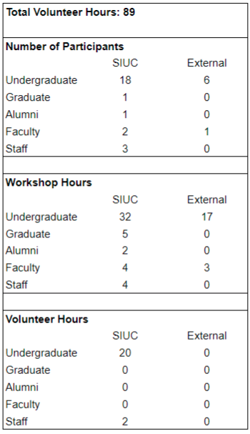
Table 1. Breakdown of Number of Participants for Design Thinking Workshops and Volunteering Events in relation to the Green Roof Project as of January 13, 2021.

Platform | Number of Followers
LinkedIn | 151
Facebook | 119
Instagram | 102

Table 2. Social Media Following as of January 13, 2021.

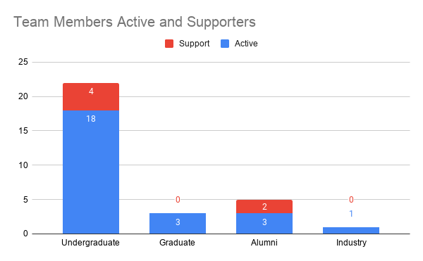
Figure 1. Breakdown of Current Green Roof Team Member Status.

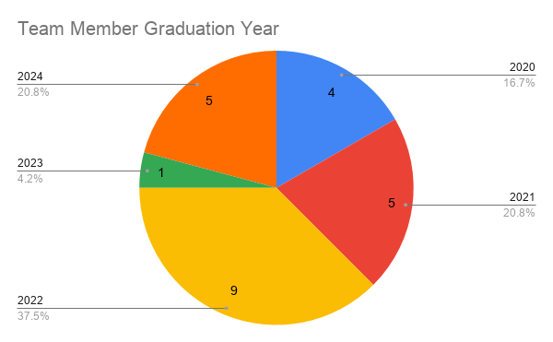
Figure 2. Breakdown of Current Green Roof Student Team Members’ Graduation Year.

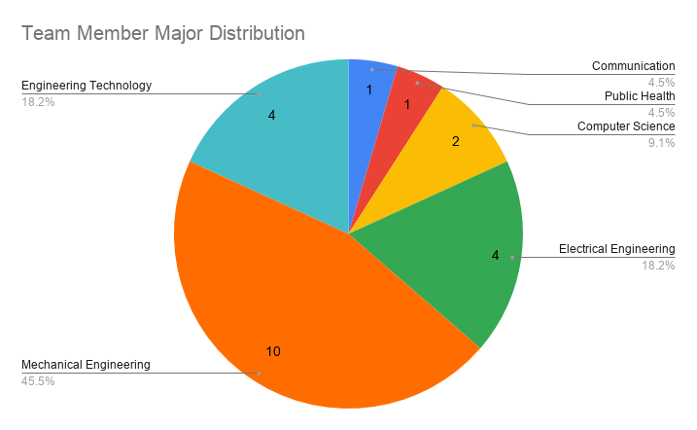
Figure 3. Breakdown of Current Green Roof Team Members’ Major of Study.

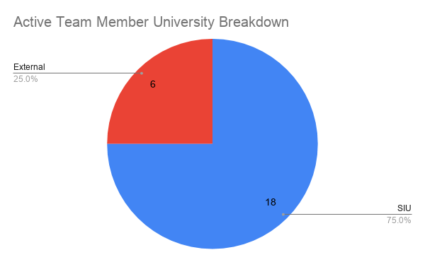
Figure 4. Breakdown of Current Green Roof Team Members’ University of Attendance.
- Summarize how your project promoted the Green Fee/Sustainability on campus including, but not limited to, flyers created, screenshots of website, signage, etc. Please include website links, if applicable. (Reminder: you are required to promote your project using at least 2 items from the awardee website promotion list.)

The Green Roof Project promoted the Green Fee/Sustainability on campus through the use of the Green Fund Marker on various media seen in the Appendix which includes the Green Roof banner, Green Roof website, and various marketing flyers.

- Provide evidence of how you used the Green Fund Marker in your project.

We have used the Green Fund Marker in several ways throughout our project which includes displaying on Design Thinking Workshop and Volunteer Event flyers, the new Green Roof’s SIU website, Green Roof Team shirts, and the SIU Green Roof’s banner. Imagery evidence can be seen in the Appendix.

- Is there anything you would do differently if you were to do a similar project in the future? If so, please describe.

For future projects, securing technical experts from the project inception will be valuable for guidance along the process as well as a clear vision of project closeout discussed at the start.

- Provide as an attachment to the email (see email address below) a minimum of 5 digital images. A minimum of one of the five images should include a person. Images should be of high a quality as possible and be attached in jpg format, if available. Images will be used to promote interest in sustainability projects on campus and may be used on our website and in other promotional material. These can be photos of the progress of the project or the completed project. Provide captions for photos here.

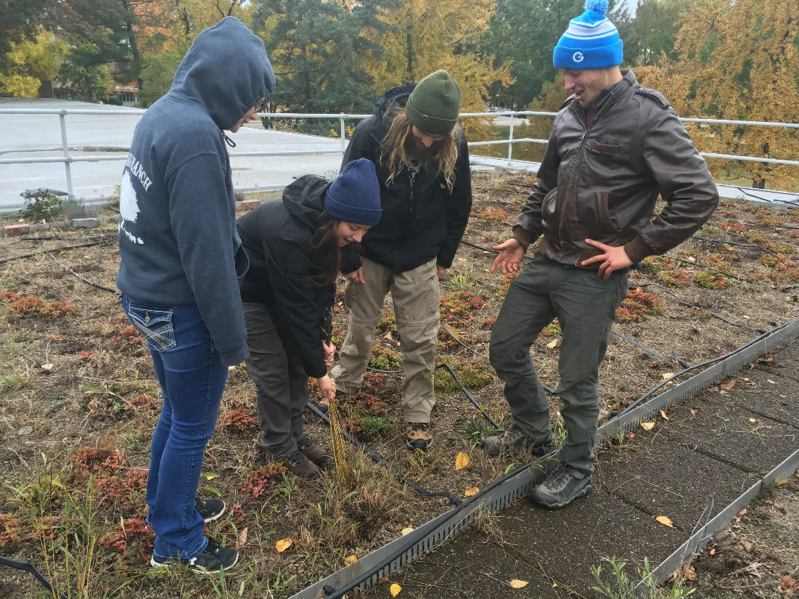
Figure 5. SIU Students Weeding the SIU Green Roof

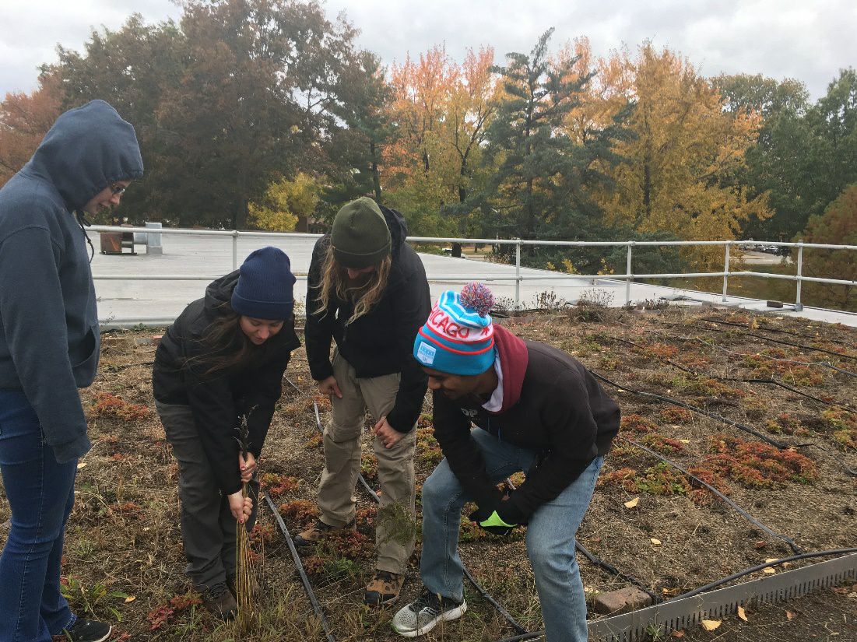
Figure 6. Students Weeding the SIU Green Roof

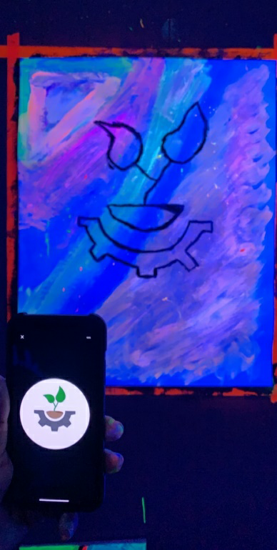
Figure 7. Artwork depicting the Green Roof Team’s Identifier

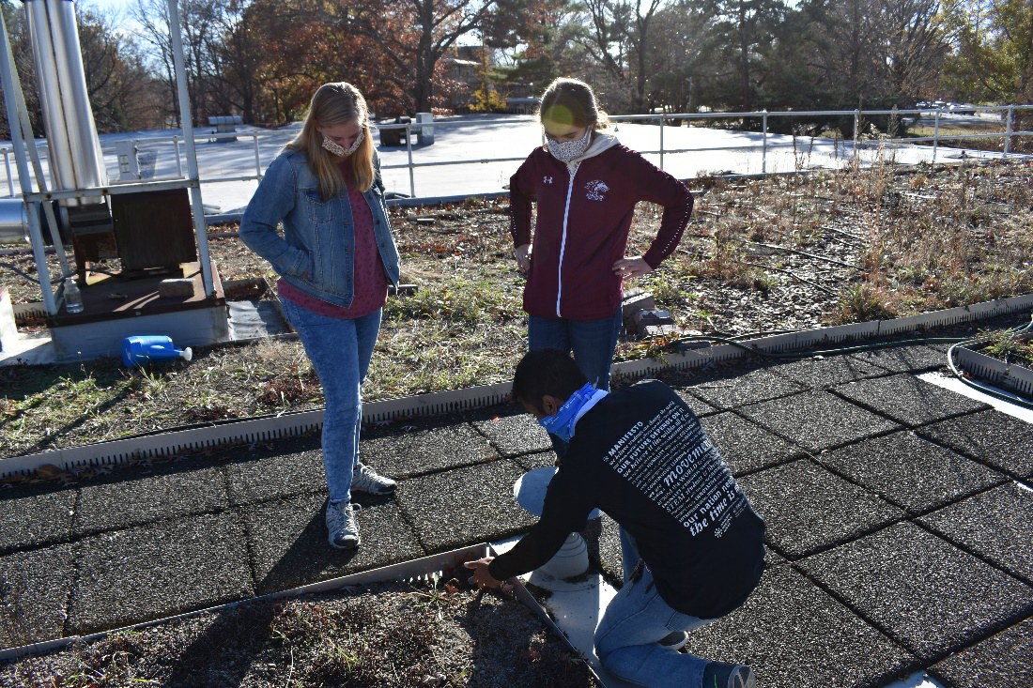
Figure 8. Students Touring the SIU Green Roof

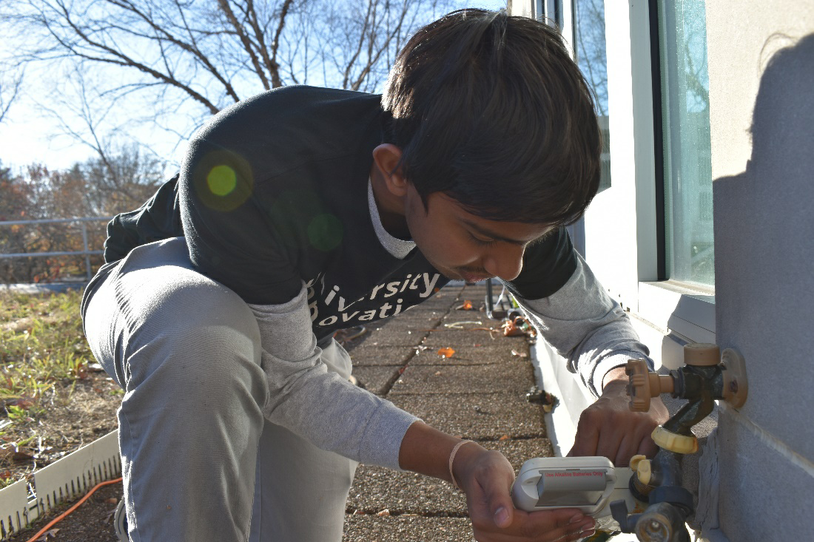
Figure 9. Green Roof Team member, Prem Rana, viewing the irrigation system

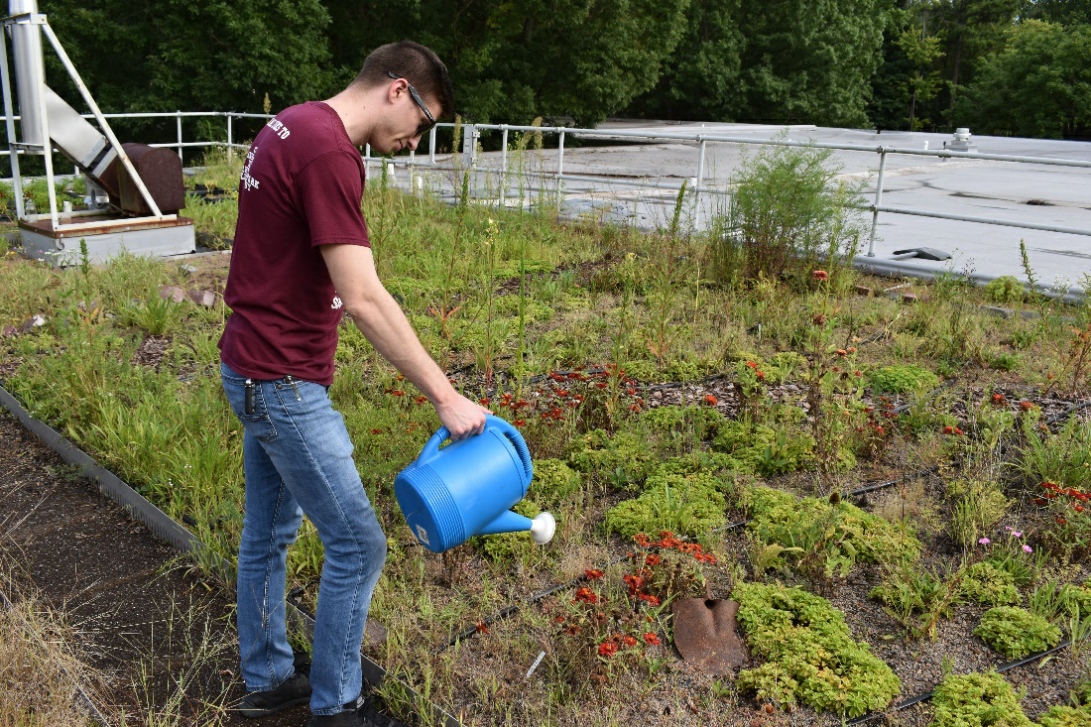
Figure 10. Green Roof Team member, Zachary Boehl, watering the native plants

- In 2-5 sentences, describe what you learned from completing the Green Fund grant process. Include a detailed response (Do not simply respond “yes” or “no.”) to at least one of the following questions to help us understand how this project has impacted your overall university experience.
  - Do you have a different understanding of sustainability now than you did at the beginning of the process?

My understanding of sustainability has expanded during the project from a sole focus on the environment (planet) into a blend of the environment with society or economy. An example of social environmental includes our efforts to raise awareness of the benefits renewable energy provides through installing wind and solar technology. An example of environmental economy includes the financial benefits of renewable energy implementation. Sustainability is important for improving environmental quality; however, efficiently using our resources and our project emphasizes the social impact of green infrastructure and renewable energy technologies.

  - Did you apply knowledge or skills learned from courses at SIU?

IMAE 450 (Project Management) – this course provided an overview of the project management process followed by an in-depth examination of the activities needed to successfully initiate, plan, schedule, and control the time and cost factors of the project.

GEOG 300i (Geography, People, Environment) – this course provided an understanding of complex relationships between humans and the natural environment, using a geographic perspective. We analyzed and understood coupled human and natural systems at multiple scales-local, regional, national, and global. With an emphasis on: 1) a science-based systems approach; 2) the role of geography as a key discipline that spans the social and physical sciences; 3) the importance of interdisciplinary perspectives; 4) issues of collaboration, institution building, and policy development.

  - Did the completion of the Green Fund grant process help to prepare you for your future career opportunities?

Completing the Green Fund Grant process prepared me for a future career in the renewable energy sector by providing me hands-on experience with project installation and management. Having the opportunity to practice the theory of the technology while building my engineering portfolio is an important and unique component of an undergraduate program.

- List suggestions for the SIU Sustainability Council to improve the Green Fund Award Process here:

A few suggestions for the SIU Sustainability Council to improve the Green Fund Award Process include: (1) workshops in the Fall to engage students to find projects, (2) project management workshops for awardees, (3) perhaps reaching out to faculty and staff before the Fall semester for potential projects students could work on if their interests align.

Appendix
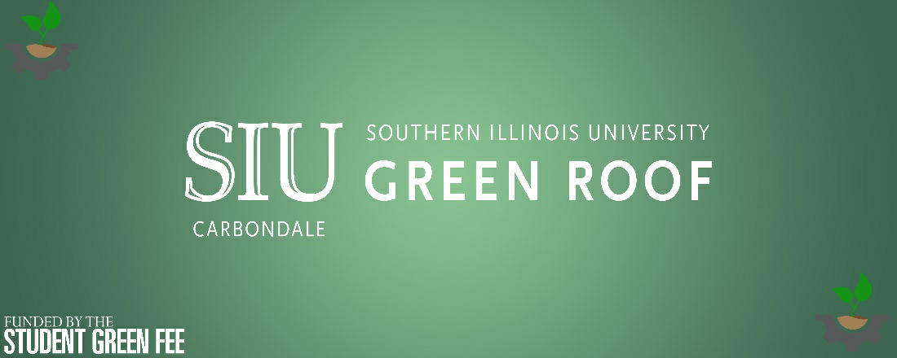
Figure 11. Green Roof Banner Digital Design

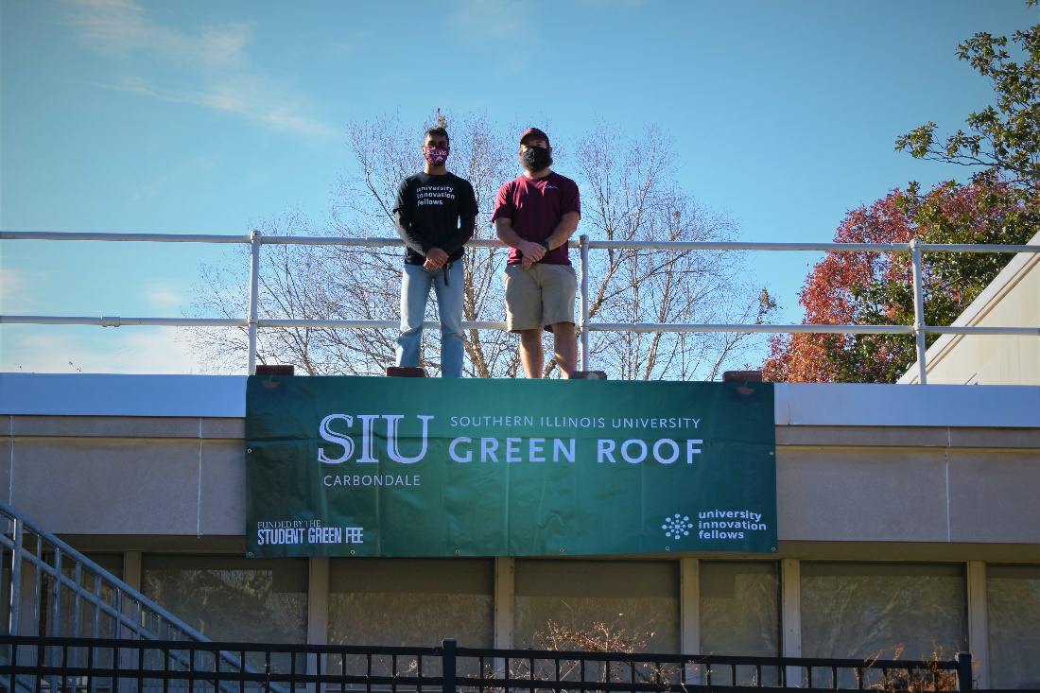
Figure 12. Green Roof Team members, Brady Kelkhoff and Nelson Fernandes, posing next to the Green Roof Banner

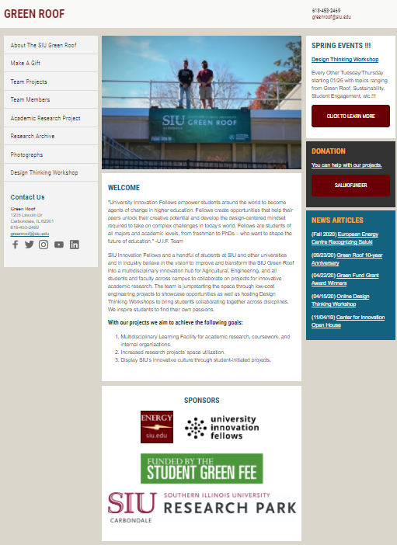
Figure 13. Home Page for the Green Roof Website, sponsored by Energy@SIU

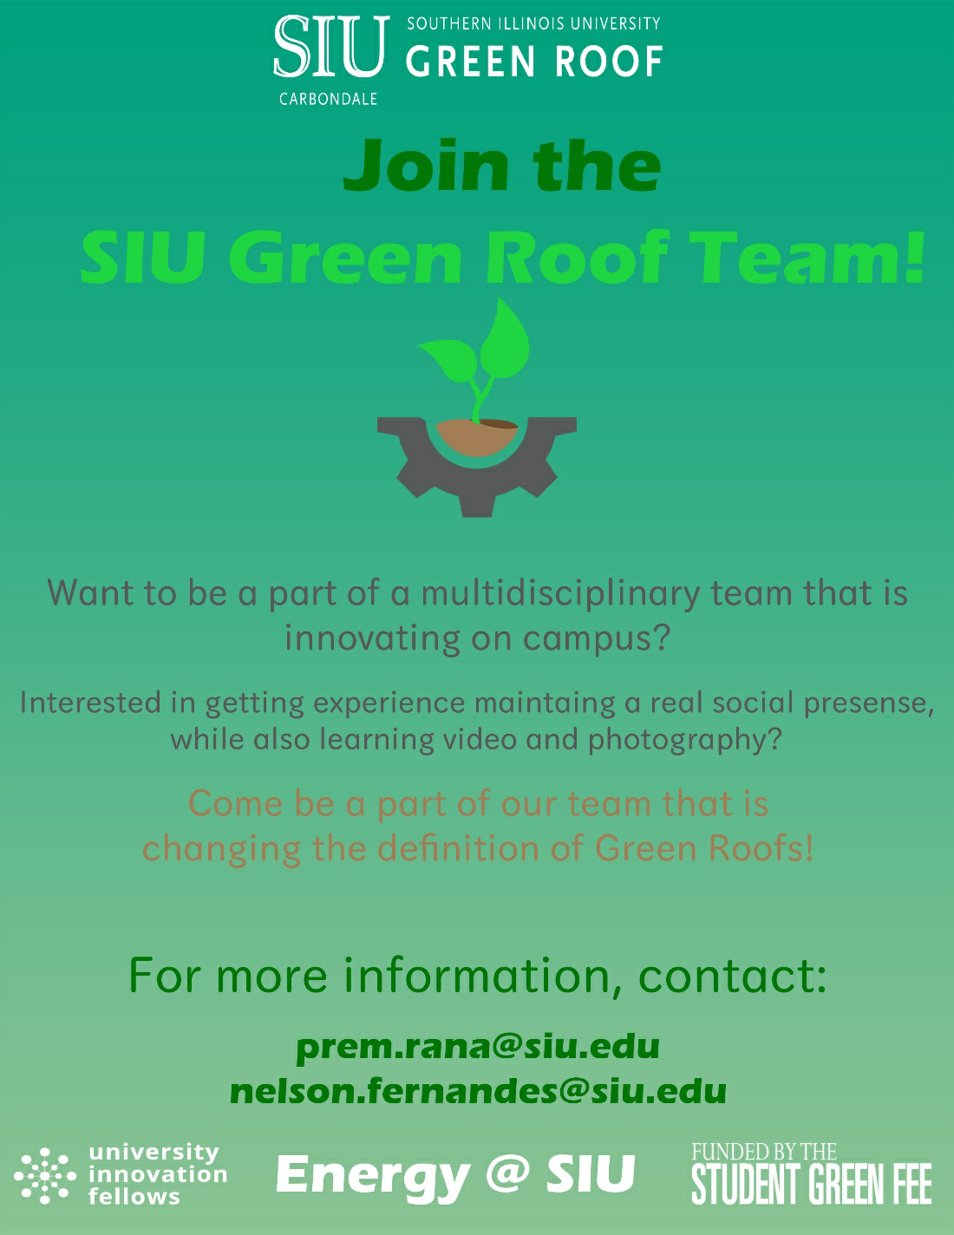
Figure 14. Marketing Flyer for Recruiting a new Marketing Team

